Structure of This Book
This book is divided into 14 chapters:
- Chapter 1 introduces the SQL language and describes its brief history. This chapter is primarily for those readers who have little or no prior SQL experience. You'll find simple examples of the core SQL statements (SELECT, INSERT, UPDATE, and DELETE) and of SQL's basic features.
- Chapter 2 describes ways to filter data in your SQL statements. You'll learn to restrict the results of a query to the rows you wish to see, and restrict the results of a data manipulation statement to the rows you wish to modify.
- Chapter 3 describes constructs used to access data from multiple, related tables. The important concepts of inner join and outer join are discussed in this chapter. The new ANSI-compliant join syntax introduced in Oracle9i is also discussed.
- Chapter 4 shows you how to generate summary information, such as totals and subtotals, from your data. Learn how to define groups of rows, and how to apply various aggregate functions to summarize data in those groups.
- Chapter 5 shows you how to use correlated and noncorrelated subqueries and inline views to solve complex problems that would otherwise require procedural code together with more than one query.
- Chapter 6 talks about handling date and time information in an Oracle database. Learn the tricks and traps of querying time-based data. Also learn about Oracle9i's many new date and time datatypes.
- Chapter 7 shows you how to use UNION, INTERSECT, and MINUS to combine results from two or more independent component queries into one.
- Chapter 8 shows you how to store and extract hierarchical information (such as in an organizational chart) from a relational table. Oracle provides several features to facilitate working with hierarchical data.
- Chapter 9 talks about two very powerful yet simple features of Oracle SQL that enable you to simulate conditional logic in what is otherwise a declarative language. CASE, an ANSI standard construct, was first introduced in Oracle8i, and was enhanced in Oracle9i.
- Chapter 10 discusses the issues involved with accessing partitions and collections using SQL. Learn to write SQL statements that operate on specific partitions and subpartitions. Also learn to query object data, nested tables, and variable arrays.
- Chapter 11 explores the integration of SQL and PL/SQL. This chapter describes how to call PL/SQL stored procedures and functions from SQL statements, and how to write efficient SQL statements within PL/SQL programs.
- Chapter 12 deals with complex grouping operations used mostly in decision support systems. We show you how to use Oracle features such as ROLLUP, CUBE, and GROUPING SETS to efficiently generate various levels of summary information required by decision support applications. We also discuss the new Oracle9i grouping features that enable composite and concatenated groupings, and the new GROUP_ID and GROUPING_ID functions.
- Chapter 13 deals with analytical queries and new analytic functions. Learn how to use ranking, windowing, and reporting functions to generate decision support information. This chapter also covers the new analytic features introduced in Oracle9i.
- Chapter 14 talks about best practices that you should follow in order to write efficient and maintainable queries. Learn which SQL constructs are the most efficient for a given situation. For example, we describe when it's better to use WHERE instead of HAVING to restrict query results. We also discuss the performance implications of using bind variables vis-a-vis literal SQL.

Conventions Used in This Book
The following typographical conventions are used in this book.
Italic
Used for filenames, directory names, table names, field names, and URLs. It is also used for emphasis and for the first use of a technical term.
Constant width
Used for examples and to show the contents of files and the output of commands.
Constant width italic
Used in syntax descriptions to indicate user-defined items.
Constant width bold
Indicates user input in examples showing an interaction. Also indicates emphasized code elements to which you should pay particular attention.
Constant width bold italic
Used in code examples to emphasize aspects of the SQL statements, or results, that are under discussion.
UPPERCASE
In syntax descriptions, indicates keywords.
lowercase
In syntax descriptions, indicates user-defined items such as variables.
[ ]
In syntax descriptions, square brackets enclose optional items.
{ }
In syntax descriptions, curly brackets enclose a set of items from which you must choose only one.
|
In syntax descriptions, a vertical bar separates the items enclosed in curly brackets, as in {TRUE | FALSE}.
...
In syntax descriptions, ellipses indicate repeating elements.
 | Indicates a tip, suggestion, or general note. For example, we use notes to point you to useful new features in Oracle9i.

 | Indicates a warning or caution. For example, we'll tell you if a certain SQL clause might have unintended consequences if not used carefully.

Comments and Questions
We have tested and verified the information in this book to the best of our ability, but you may find that features have changed or that we have made mistakes. If so, please notify us by writing to:
O'Reilly & Associates
1005 Gravenstein Highway North
Sebastopol, CA 95472
(800) 998-9938 (in the United States or Canada)
(707) 829-0515 (international or local)
(707) 829-0104 (FAX)
You can also send messages electronically. To be put on the mailing list or request a catalog, send email to:
info@oreilly.com
To ask technical questions or comment on the book, send email to:
bookquestions@oreilly.com
We have a web site for this book, where you can find examples and errata (previously reported errors and corrections are available for public view there). You can access this page at:
http://www.oreilly.com/catalog/mastorasql
For more information about this book and others, see the O'Reilly web site:
http://www.oreilly.com

Acknowledgments
We are indebted to a great many people who have contributed in the development and production of this book. We owe a huge debt of gratitude to Jonathan Gennick, the editor of the book. Jonathan's vision for this book, close attention to details, and exceptional editing skills are the reasons this book is here today.
Our sincere thanks to our technical reviewers: Diana Lorentz, Jeff Cox, Stephan Andert, Rich White, Peter Linsley, and Chris Lee, who generously gave their valuable time to read and comment on a draft copy of this book. Their contributions have greatly improved its accuracy, readability, and value.
This book certainly would not have been possible without a lot of hard work and support from the skillful staff at O'Reilly & Associates, including Ellie Volckhausen and Emma Colby, the cover designers, David Futato, the interior designer, Neil Walls, who converted the files, Colleen Gorman, the copyeditor and production editor, Rob Romano and Jessamyn Read, the illustrators, Sheryl Avruch and Ann Schirmer, who provided quality control, and Tom Dinse, the indexer. Also, thanks to Tim O'Reilly for taking time to go through this book and providing valuable feedback.
From Sanjay
My heartfelt thanks to my coauthor Alan for his outstanding technical skills, and for his constant cooperation during the writing of this book. Special thanks to Jonathan for not only editing this book, but also for providing me with remote access to his Oracle9i database.
My adventure with Oracle started in the Tribology Workbench project at Tata Steel, Jamshedpur, India. Sincere thanks to my co-workers in the Tribology Workbench project for all the experiments and explorations we did during our learning days with Oracle. Special thanks to Sarosh Muncherji, the Deputy Team Leader, for picking me up for the project and then pushing me into the Oracle world by assigning me the responsibility of being the DBA. Ever since, Oracle database technology has become a way of life for me.
Sincere thanks to my co-workers at i2 Technologies for support and encouragement.
Last, but not the least, I thank my wife, Sudipti, for her support, understanding, and constant encouragement.
From Alan
I would like to thank my coauthor Sanjay and my editor Jonathan Gennick for sharing my vision for this book, and for their technical and editorial prowess. I would never have reached the finish line without your help and encouragement.
Most of all, I would like to thank my wife, Nancy, for her support, patience, and encouragement, and my daughters, Michelle and Nicole, for their love and inspiration.

Chapter 1. Introduction to SQL
In this introductory chapter, we explore the origin and utility of the SQL language, demonstrate some of the more useful features of the language, and define a simple database design from which most examples in the book are derived.

1.1 What Is SQL?
SQL, which stands for Structured Query Language, is a special-purpose language used to define, access, and manipulate data. SQL is nonprocedural, meaning that it describes the necessary components (i.e., tables) and desired results without dictating exactly how results should be computed. Every SQL implementation sits atop a database engine, whose job it is to interpret SQL statements and determine how the various data structures in the database should be accessed in order to accurately and efficiently produce the desired outcome.
The SQL language includes two distinct sets of commands: Data Definition Language (DDL) is the subset of SQL used to define and modify various data structures, while Data Manipulation Language (DML) is the subset of SQL used to access and manipulate data contained within the data structures previously defined via DDL. DDL includes numerous commands for handling such tasks as creating tables, indexes, views, and constraints, while DML is comprised of just four statements:
INSERT
Adds data to a database.
UPDATE
Modifies data in a database.
DELETE
Removes data from a database.
SELECT
Retrieves data from a database.
Some people feel that DDL is the sole property of database administrators, while database developers are responsible for writing DML statements, but the two are not so easily separated. It is difficult to efficiently access and manipulate data without an understanding of what data structures are available and how they are related; likewise, it is difficult to design appropriate data structures without knowledge of how the data will be accessed. That being said, this book deals almost exclusively with DML, except where DDL is presented in order to set the stage for one or more DML examples. The reasons for focusing on just the DML portion of SQL include:
- DDL is well represented in various books on database design and administration as well as in SQL reference guides.
- Most database performance issues are the result of inefficient DML statements.
- Even with a paltry four statements, DML is a rich enough topic to warrant not just one book, but a whole series of books.^{[1]}
^{[1]} Anyone who writes SQL in an Oracle environment should be armed with the following three books: a reference guide to the SQL language, such as Oracle SQL: The Essential Reference (O'Reilly), a performance-tuning guide, such as Oracle SQL Tuning Pocket Reference (O'Reilly), and the book you are holding, which shows how to best utilize and combine the various features of Oracle's SQL implementation.
So why should you care about SQL? In this age of Internet computing and n-tier architectures, does anyone even care about data access anymore? Actually, efficient storage and retrieval of information is more important than ever:
- Many companies now offer services via the Internet. During peak hours, these services may need to handle thousands of concurrent requests, and unacceptable response times equate to lost revenue. For such systems, every SQL statement must be carefully crafted to ensure acceptable performance as data volumes increase.
- We can store a lot more data today than we could five years ago. A single disk array can hold tens of terabytes of data, and the ability to store hundreds of terabytes is just around the corner. Software used to load or analyze data in these environments must harness the full power of SQL in order to process ever-increasing data volumes within constant (or shrinking) time windows.
Hopefully, you now have an appreciation for what SQL is and why it is important. The next section will explore the origins of the SQL language and the support for the SQL standard in Oracle's products.

1.2 A Brief History of SQL
In the early 1970s, an IBM research fellow named Dr. E. F. Codd endeavored to apply the rigors of mathematics to the then-untamed world of data storage and retrieval. Codd's work led to the definition of the relational data model and a language called DSL/Alpha for manipulating data in a relational database. IBM liked what they saw, so they commissioned a project called System/R to build a prototype based on Codd's work. Among other things, the System/R team developed a simplified version of DSL called SQUARE, which was later renamed SEQUEL, and finally renamed SQL.
The work done on System/R eventually led to the release of various IBM products based on the relational model. Other companies, such as Oracle, rallied around the relational flag as well. By the mid 1980's, SQL had gathered sufficient momentum in the marketplace to warrant oversight by the American National Standards Institute (ANSI). ANSI released its first SQL standard in 1986, followed by updates in 1989, 1992, and 1999.
Thirty years after the System/R team began prototyping a relational database, SQL is still going strong. While there have been numerous attempts to dethrone relational databases in the marketplace, well-designed relational databases coupled with well-written SQL statements continue to succeed in handling large, complex data sets where other methods fail.
1.2.1 Oracle's SQL Implementation
Given that Oracle was an early adopter of the relational model and SQL, one might think that they would have put a great deal of effort into conforming with the various ANSI standards. For many years, however, the folks at Oracle seemed content that their implementation of SQL was functionally equivalent to the ANSI standards without being overly concerned with true compliance. Beginning with the release of Oracle8i, however, Oracle has stepped up its efforts to conform to ANSI standards and has tackled such features as the CASE statement and the left/right/full outer join syntax.
Ironically, the business community seems to be moving in the opposite direction. A few years ago, people were much more concerned with portability and would limit their developers to ANSI-compliant SQL so that they could implement their systems on various database engines. Today, companies tend to pick a database engine to use across the enterprise and allow their developers to use the full range of available options without concern for ANSI-compliance. One reason for this change in attitude is the advent of n-tier architectures, where all database access can be contained within a single tier instead of being scattered throughout an application. Another possible reason might be the emergence of clear leaders in the DBMS market over the last five years, such that managers perceive less risk in which database engine they choose.
1.2.2 Theoretical Versus Practical Terminology
If you were to peruse the various writings on the relational model, you would come across terminology that you will not find used in this book (such as relations and tuples). Instead, we use practical terms such as tables and rows, and we refer to the various parts of an SQL statement by name rather than by function (i.e., "SELECT clause" instead of projection). With all due respect to Dr. Codd, you will never hear the word tuple used in a business setting, and, since this book is targeted toward people who use Oracle products to solve business problems, you won't find it here either.

1.3 A Simple Database
Because this is a practical book, it contains numerous examples. Rather than fabricating different sets of tables and columns for every chapter or section in the book, we have decided to draw from a single, simple schema for most examples. The subject area that we chose to model is a parts distributor, such as an auto-parts wholesaler or medical device distributor, in which the business fills customer orders for one or more parts that are supplied by external suppliers. Figure 1-1 shows the entity-relationship model for this business.
Figure 1-1. The parts distributor model
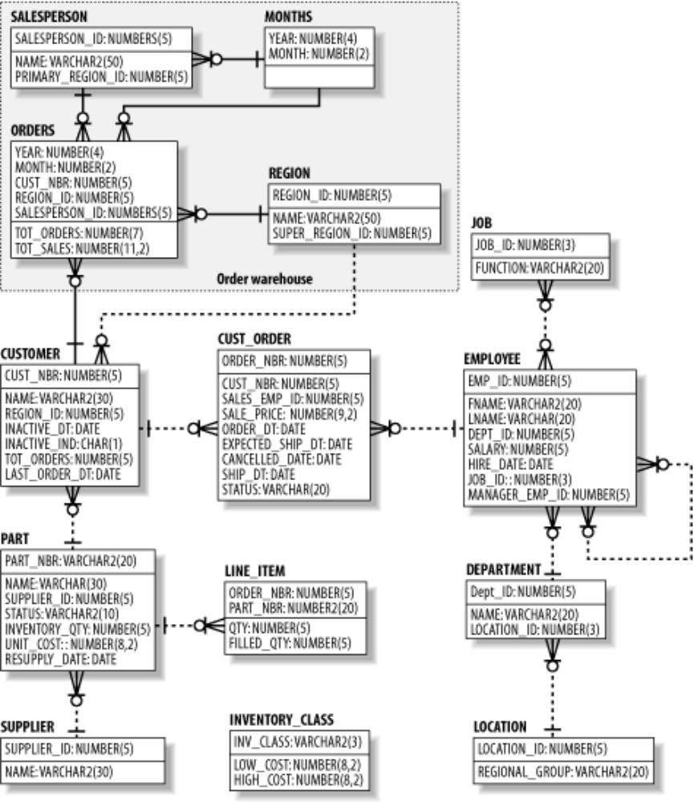
If you are unfamiliar with entity-relationship models, here is a brief description of how they work. Each box in the model represents an entity, which correlates to a database table.^{[2]} The lines between the entities represents the relationships between tables, which correlate to foreign keys. For example, the CUST_ORDER table holds a foreign key to the employee table, which signifies the salesperson responsible for a particular order. Physically, this means that the CUST_ORDER table contains a column holding employee ID numbers, and that, for any given order, the employee ID number indicates the employee who sold that order. If you find this confusing, simply use the diagram as an illustration of the tables and columns found within our database. As you work your way through the SQL examples in this book, return occasionally to the diagram, and you should find that the relationships start making sense.
^{[2]} Depending on the purpose of the model, entities may or may not correlate to database tables. For example, a logical model depicts business entities and their relationships, whereas a physical model illustrates tables and their primary/foreign keys. The model in Figure 1-1 is a physical model.

